**Ip Addressing**

* There are two type of ip are **ipv4** and **ipv6**
* Ipv4 there are two type of ip are **public ip** and **private ip** .

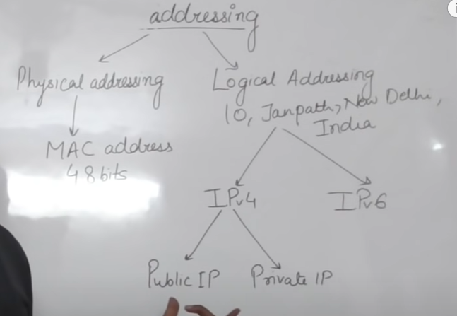

* 32bit logical address hote hai eak ip mein

4 octet hote hai har eak ip mein , matlab 4 sein jada octet eak ip mein nahi ho sakte ,neeche vali pics mein jo ip kein nadir line khicha hai 4 vo har eak octate hai bas line ki jagah hum ip mein . laga dete hai samjhane kein liye mene line lagaya ha bas ,har eak octate **8 bit** ka hota hai . matlab 8*4=32

For e.x,

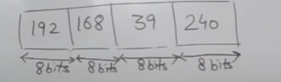

* Maximum value har eak octate mein 256 ho sakti hai bas usase jada nahi aur minimum 0 .but maximum hum 256 likhate nahi kyu ki hardum 1 ip garbage mein chali jati hai .isliye maximum 255 tak hum define karate hai .

For e.x.,

255.255.255.255 (correct ip)

255.255.255.256 (wrong ip)

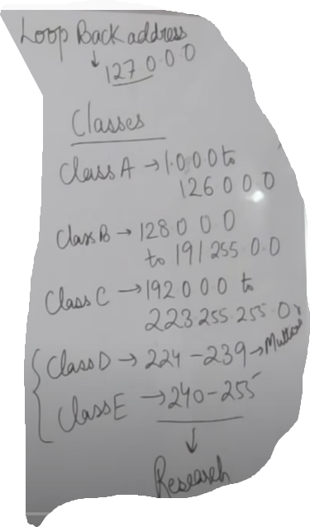

-> **class A** hum tab use karte hai jab humko bahut jada ip ki requirement ho koi bahut bada infrastructure ho aur mujhe jada ip ki jarurat ho toh uske liye hum class A use karte hai ,uke baad **class B** jo hai vo class A sein kam hota hai aur **class c** mein agar humko kam ip ya chotte infrastructure ki jarurat hai tab use karenge .

-> **class D** hum tab use karenge jab humko multitask akrna ho

-> **class E** reserverd hai

-> **127.0.0.0** vali ip reserved ip hoti hai is ip ko hum apaane cmd mein dal kar dekhenge toh isase ye pata chalega ki humare pass internet access ho raha ya nahi .

**CIDR VALUE**

Class A = 8

Class B = 16

Class C = 24

Class D = 32

**CONVERT IP ADDRESS TO BINARY**

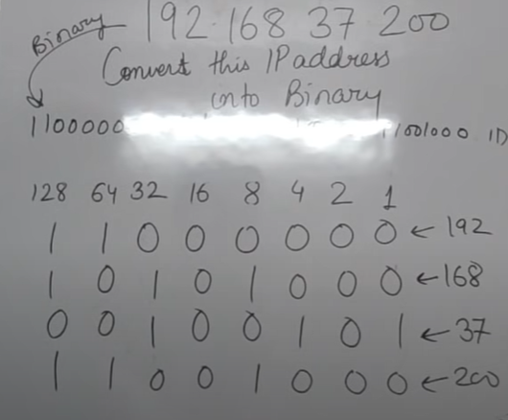

**Private Ip:-**

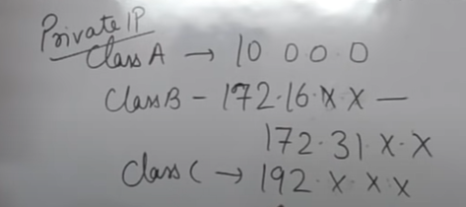

**Difference between public ip and private ip**

* **Public ip** humko khreedani padti hai but **private ip** ko humein kharedane ki jarurat nahi padti.
* **Public ip** kein through hum internet ko access kar sakte hai but **private ip** kein through hum internet ko access nahi kar sakte.
* **Private ip** hum use karate hai locally agar humko kuch computer aapas mein connect karne hai toh uske liye hum private ip use karte hai , kisi college ya office mein eak dusare sein computer aapas mein connect karne kein liye hum private ip ka use karte hai .

**Router**

* Router ka kaam hi yahi hota hai ki 2 network kein beech mei communicate karana .